

Semester One Examination, 2018

Question/Answer booklet

MATHEMATICS

SOLUTIONS
SPECIALIST
UNIT 1

Section Two:

Calculator-assumed

Student number: In figures

In words

Your name

Time allowed for this section
Reading time before commencing work: ten minutes
Working time: one hundred minutes

Materials required/recommended for this section
To be provided by the supervisor
This Question/Answer booklet
Formula sheet (retained from Section One)

To be provided by the candidate
Standard items: pens (blue/black preferred), pencils (including coloured), sharpener,
correction fluid/tape, eraser, ruler, highlighters

Special items: drawing instruments, templates, notes on two unfolded sheets of A4 paper, and up to three calculators approved for use in this examination

Important note to candidates
No other items may be taken into the examination room. It is your responsibility to ensure that you do not have any unauthorised material. If you have any unauthorised material with you, hand it to the supervisor before reading any further.

Structure of this paper

Section | Number of questions available | Number of questions to be answered | Working  time (minutes) | Marks available | Percentage of examination
Section One:  Calculator-free | 8 | 8 | 50 | 53 | 35
Section Two:  Calculator-assumed | 13 | 13 | 100 | 97 | 65
 |  |  |  | Total | 100

Instructions to candidates

1. The rules for the conduct of examinations are detailed in the school handbook. Sitting this examination implies that you agree to abide by these rules.

2. Write your answers in this Question/Answer booklet.

3. You must be careful to confine your response to the specific question asked and to follow any instructions that are specified to a particular question.

4. Supplementary pages for the use of planning/continuing your answer to a question
have been provided at the end of this Question/Answer booklet. If you use these pages to continue an answer, indicate at the original answer where the answer is continued, i.e. give the page number.

5. Show all your working clearly. Your working should be in sufficient detail to allow your answers to be checked readily and for marks to be awarded for reasoning. Incorrect answers given without supporting reasoning cannot be allocated any marks. For any question or part question worth more than two marks, valid working or justification is required to receive full marks. If you repeat any question, ensure that you cancel the answer you do not wish to have marked.

6. It is recommended that you do not use pencil, except in diagrams.

7. The Formula sheet is not to be handed in with your Question/Answer booklet.

Section Two: Calculator-assumed 65% (97 Marks)
This section has thirteen (13) questions. Answer all questions. Write your answers in the spaces provided.

Working time: 100 minutes.

Question 9 (7 marks)
(a) In the diagram below, points $A$ and $B$ lie on a circle, $DE$ is a tangent to the circle at $C$, $∠ACD=64°$ and $∠BAC=49°$. Determine the sizes of $∠ABC, ∠BCE$ and $∠BCA$. (3 marks)

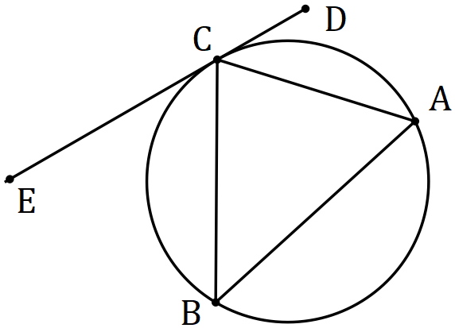
Solution
$$∠ABC=∠ACD=64°$$

$$∠BCE=∠BAC=49°$$

$$∠BCA=∠180-64-49=67°$$

Specific behaviours
$∠ABC$
$∠BCE$
$∠BCA$

(b) In the next diagram, $P, Q$ and $R$ lie on a circle with centre $O$ and $∠POR=x°$. Determine, with reasons, the size of $∠PQR$ in terms of $x$. (4 marks)
Solution
$\text{Reflex} ∠POR=α=360-x$
(Angle sum at point)

$∠PQR=\frac{1}{2}α$
(Angle on arc at centre twice that on circumference)
$∠PQR=\frac{1}{2}\left(360-x\right)=180-\frac{1}{2}x$

Specific behaviours
expression for reflex angle
reason
$∠PQR$
reason
(Or other methods)

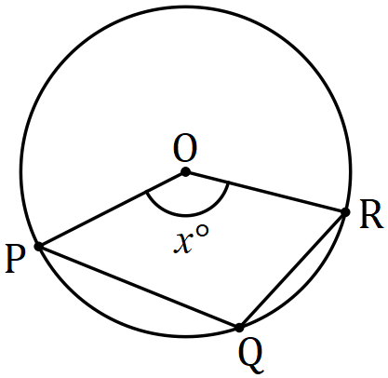

Question 10 (7 marks)
(a) A body travels with a velocity $12i-5j$ ms⁻¹. Determine its speed and the bearing on which it is moving, assuming the positive $y$-axis to be due north. (3 marks)

Solution
$$\text{Speed}=\sqrt{{12}^{2}+{(-5)}^{2}}=13 \text{m/s}$$

$$\text{Angle}=\tan^{-1}\left(\frac{-5}{12}\right)=-22.6°$$

$$\text{Bearing}=360n-(-22.6-90)=112.6°$$

Specific behaviours
speed
angle
bearing

(b) Given that $λ\left(5i-2j\right)+μ\left(-7i+4j\right)=25i-13j$, determine the values of $λ$ and $μ$.
(4 marks)
Solution
$$5λ-7μ=25$$
$$-2λ+4μ=-13$$

$$λ=1.5$$
$$μ=-2.5$$

Specific behaviours
equates $i$-coefficients
equates $j$-coefficients
value of $λ$
value of $μ$

Question 11 (8 marks)
Two forces, $F_{1}=230 \text{N}$ and $F_{2}=272 \text{N}$, act on a body at $O$, and make angles of $α=15°,$ and $β=20°$ respectively with the vertical $OP$, as shown in the diagram below.

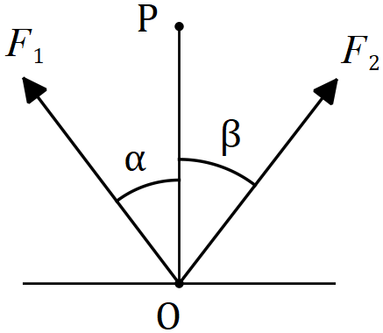

(a) Determine the magnitude of the resultant force and the angle it makes with the vertical.
(5 marks)
Solution
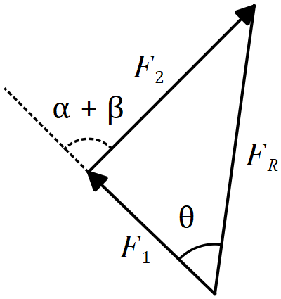 | $$F_{R}=\sqrt{2{30}^{2}+{272}^{2}-2\left(230\right)\left(272\right)\cos{145}}$$  $$F_{R}=479 N$$  $$\frac{\sin{θ}}{272}=\frac{\sin{145}}{478.9}$$  $$θ=19°$$  $$\text{Angle}=19°-15°=4°$$
Specific behaviours
sketch with forces nose to tail
indicates use of cosine rule for magnitude
magnitude
indicates use of sine rule for angle
angle with vertical

(b) The magnitude of $F_{2}$ is to be adjusted so that the direction of the resultant is vertical. Determine the required magnitude of $F_{2}$. (3 marks)
Solution
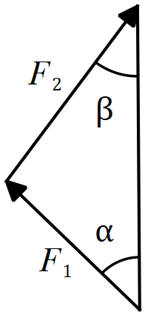 | $$\frac{\sin{15}}{F_{2}}=\frac{\sin{20}}{230}$$  $$F_{2}=174 \text{N}$$
Specific behaviours
sketch
indicates use of sine rule
magnitude

Question 12 (6 marks)
The largest Australian family recently met with the largest English family. Between them, these two families had $37$ children.

(a) Three of the children were chosen at random to feature in a TV documentary about the two families. Determine the number of different selections of three children that were possible. (1 mark)
Solution
$$\left(\begin{matrix}37 \\ 3\end{matrix}\right)=7 770$$

Specific behaviours
correct number

(b) Prove that at least four of the children were born in the same month of the year.
(2 marks)
Solution
Let the 12 months of the year be the pigeon-holes and the 37 children the pigeons. If 3 pigeons are placed in each of the 12 pigeon-holes, then there is still one left over, and so at least one of the pigeon-holes must have at least 4 pigeons (children).

Specific behaviours
defines pigeons and pigeon-holes
uses pigeon-hole principle

There were more children in the English family than the Australian family and the English children all had blue, brown, hazel or grey coloured eyes.

(c) Show that at least five English children had the same eye colour. (3 marks)
Solution
$$37÷2=18.5⇒\text{minimum of} 19 \text{from England}$$

$4$ eye colours are the pigeon-holes and $19$ children are pigeons. If $4$ pigeons placed in each pigeon hole there are $3$ left over and so at least one of the pigeon-holes must have at least $5$ pigeons (children with same coloured eyes).

Specific behaviours
minimum number of English children
defines pigeons and pigeon-holes
uses pigeon-hole principle

Question 13 (8 marks)
(a) Determine the size of angles $a$ and $b$ in the diagram below, where $Q$ and $S$ lie on the circumference of the circle with diameter $PR$. (3 marks)

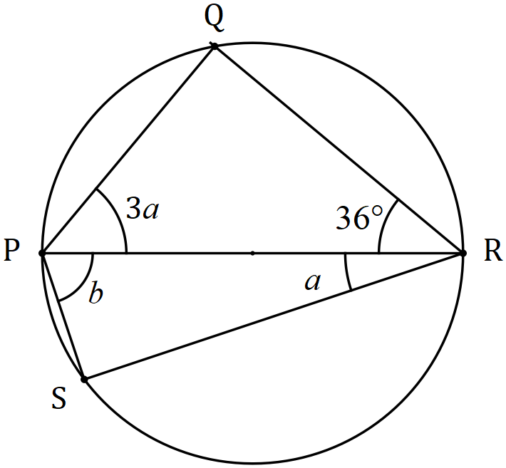
Solution
$$3a+36=90$$
$$a=18°$$
$$b=90-18=72°$$

Specific behaviours
uses angle in semi-circle
value of $a$
value of $b$

(b) Triangle $ABC$ has sides of length $AB=5$ cm, $BC=7$ cm and $AC=9$ cm. Prove, using the method of contradiction, that if $AC$ is a diameter of a circle then $B$ does not lie on the circumference of the circle. (5 marks)

Solution
Assume that $B$ does lie on the circumference of the circle.
Then $∠ABC=90°$ (angle in semi-circle)
Hence $AB^{2}+BC^{2}=AC^{2}$ (Pythagoras' theorem)
But $5^{2}+7^{2}=74≠81=9^{2}$.
Hence assumption must be incorrect and so $B$ does not lie on the circumference.

Specific behaviours
assumes contradictory statement
states angle in semi-circle
deduces relationship between sides
shows contradiction
summarises

Question 14 (8 marks)
(a) Simplify $\left(4a-2b\right)∙(a-3b)$ given that $\left|a\right|=5, \left|b\right|=3$ and vector $a$ is parallel and in the opposite direction to vector $b$. (4 marks)
Solution
$$\left(4a-2b\right)∙\left(a-3b\right)=4a∙a-12a∙b-2b∙a+6b∙b \\ =4a^{2}-12(-ab)-2(-ab)+6b^{2} \\ =4\left(5^{2}\right)+14\left(3×5\right)+6\left(3^{2}\right) \\ =364$$

Specific behaviours
expands scalar product
indicates $a∙b=-ab$
substitutes magnitudes
simplifies

(b) Using $\vec{OA}=a$ and $\vec{OC}=c$, demonstrate a vector method to show that if the diagonals $\vec{OB}$ and $\vec{AC}$ of parallelogram $OABC$ are perpendicular, then the parallelogram is a rhombus.
(4 marks)
Solution
$$\vec{OB}=a+c$$
$$\vec{AC}=c-a$$
$$\text{Given} \vec{OB} \text{and} \vec{AC} \text{ are perpendicular then} \left(a+c\right)∙\left(c-a\right)=0$$
$$a∙c-a∙a+c∙c-c∙a=0$$
$${\left|c\right|}^{2}={\left|a\right|}^{2}$$
$$\text{Hence lengths of sides of }OABC\text{ are congruent and so} OABC \text{is a rhombus}.$$

Specific behaviours
determines vectors for diagonals
uses scalar product
expands scalar product
explains that sides must be congruent

Question 15 (9 marks)
(a) In the diagram below, $PA$ and $PC$ are tangents to the circle, with $PA=58$ cm. Secant $PB$ cuts the circle at $D$, so that $PD=40$ cm. Determine the lengths of $PC$ and $BD$. (4 marks)

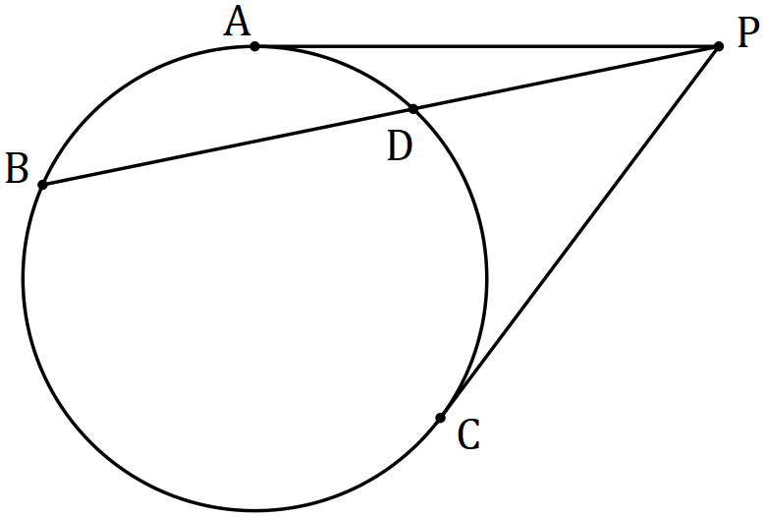
Solution
$$PC=PA=58 \text{cm}$$

$$PD×PB=AP^{2}$$

$$40\left(40+BD\right)={58}^{2}$$

$$BD=44.1 \text{cm}$$

Specific behaviours
value of $PC$
indicates use of tangent-secant theorem
equation for $BD$
value of $BD$

(b) In the diagram below, $A, B$ and $C$ lie on the circumference of the circle with centre $O$, with $AC$ intersecting $OB$ at $D$. Prove that $∠DAO=∠DBC-∠DCB$. (5 marks)

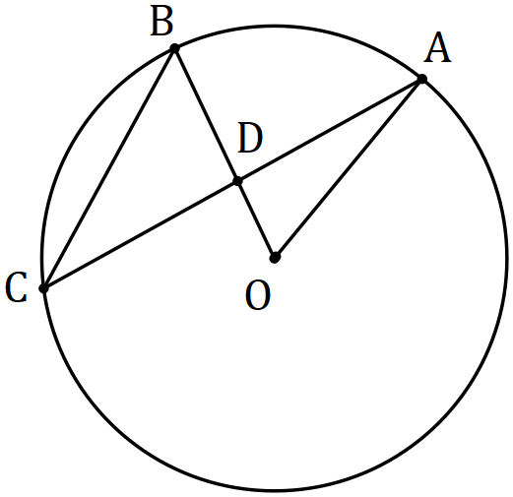
Solution
$∠DAO+∠DOA=∠BDA=∠DBC+∠DCB$
(sum of exterior angles equal)

But $∠DOA=∠BOA=2 ∠ACB=2∠DCB$
(angle at centre-circumference)

Hence $∠DAO+2∠DCB=∠DBC+∠DCB$

And so $∠DAO=∠DBC-∠DCB$

Specific behaviours
derives first equation
reasoning for first equation
uses angle at centre-circumference
substitutes
simplifies

Question 16 (9 marks)
(a) Determine the number of integers between $1$ and $370$ that are divisible by $4$ or $7$.
(4 marks)
Solution
$$370÷4=92.5⇒92 \text{divisible by} 4$$

$$370÷7=52.8…⇒52 \text{divisible by} 7$$

$$370÷28=13.2…⇒13 \text{divisible by both}$$

$$n=92+52-13=131$$

Specific behaviours
divisible by 4 & 7
divisible by 28
use of inclusion-exclusion principle
correct number

(b) A pigeon fancier has $5$ Florentine, $6$ King and $8$ Maltese pigeons and must choose three of them to enter in a local show. Determine the number of different ways the three pigeons can be chosen if

(i) there are no restrictions. (1 mark)
Solution
$$\left(\begin{matrix}19 \\ 3\end{matrix}\right)=969$$

Specific behaviours
correct number

(ii) the fancier decides to take one of each breed. (2 marks)
Solution
$$\left(\begin{matrix}5 \\ 1\end{matrix}\right)×\left(\begin{matrix}6 \\ 1\end{matrix}\right)×\left(\begin{matrix}8 \\ 1\end{matrix}\right)=240$$

Specific behaviours
uses multiplication principle
correct number

(iii) the fancier decides to take at least two Maltese pigeons. (2 marks)
Solution
$$\left(\begin{matrix}8 \\ 2\end{matrix}\right)\left(\begin{matrix}11 \\ 1\end{matrix}\right)+\left(\begin{matrix}8 \\ 3\end{matrix}\right)\left(\begin{matrix}11 \\ 0\end{matrix}\right)=308+56=364$$

Specific behaviours
indicates two cases
correct number

Question 17 (6 marks)
Three vectors are $u=ai+bj, v=-3i+5j$ and $w=-i+4j$.

(a) Determine the vector projection of $v$ on $w$ in exact form. (2 marks)
Solution
$$\left[v∙w\right]×\frac{w}{{\left|w\right|}^{2}}=\left[\left(\begin{matrix}-3 \\ 5\end{matrix}\right)∙\left(\begin{matrix}-1 \\ 4\end{matrix}\right)\right]×\frac{1}{17}\left(\begin{matrix}-1 \\ 4\end{matrix}\right)$$

$$=-\frac{23}{17}i+\frac{92}{17}j$$

Specific behaviours
indicates suitable form of projection
solution in exact form

(b) If $u$ has the same magnitude as $v$ and is perpendicular to $w$, determine the exact values of the coefficients $a$ and $b$. (4 marks)
Solution
$$a^{2}+b^{2}={\left(-3\right)}^{2}+5^{2}=34$$

$$-a+4b=0$$

$$\text{Using CAS,} a=4\sqrt{2} \text{and} b=\sqrt{2}$$
$$\text{or}$$
$$a=-4\sqrt{2} \text{and} b=-\sqrt{2}$$

Specific behaviours
equation from magnitudes
equation from perpendicular
one solution
both solutions

Question 18 (7 marks)
(a) In the diagram below, points $B$ and $C$ lie on the minor arc $AD$ of the circle with centre $O$. The lengths of chords $AB$ and $CD$ are congruent, $∠BOC=37°$ and $∠AOD=163°$. Determine the size of $∠CBD$. (3 marks)

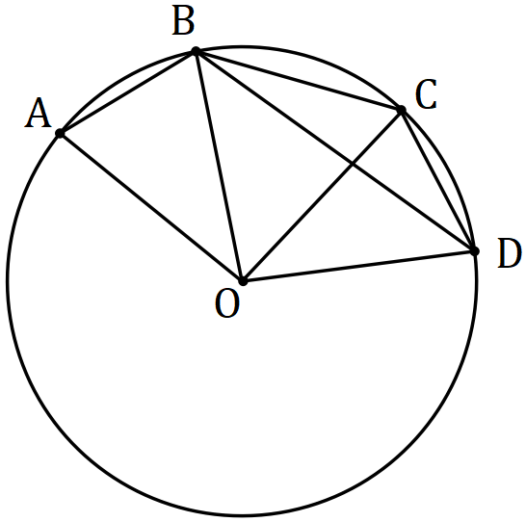
Solution
$$∠AOB=∠COD=\frac{163-37}{2}=63°$$

$$∠CBD=\frac{1}{2}∠COD=31.5°$$

Specific behaviours
indicates equal angles on equal chords
size of $∠COD$
size of $∠CBD$

(b) Line segment $AC$ intersects line segment $BD$ at $N$. Given that $AC$ and $BD$ are non-parallel and the lengths $AN, AC, BN$ and $BD$ are 6, 41, 21 and 31 cm respectively, explain whether the points $A, B, C$ and $D$ are concyclic. (4 marks)

Solution
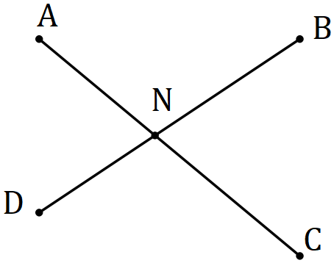

$$CN=41-6=35, DN=31-21=10$$

$$AN.CN=BN.DN$$

$$6×35=210=21×10$$

Concyclic, as interval lengths satisfy the intersecting chord theorem.

Specific behaviours
sketch
uses correct chord lengths
uses property of intersecting chords
explanation

Question 19 (8 marks)
(a) Triangle $ABC$ has vertices with position vectors $A\left(2, -6\right), B(-3, 14)$ and $C(6, 8)$. Point $P$ lies on side $BC$ so that $2\vec{BP}=\vec{PC}$. Determine the vector $\vec{AP}$. (4 marks)
Solution
$$\vec{BC}=\left(\begin{matrix}6 \\ 8\end{matrix}\right)-\left(\begin{matrix}-3 \\ 14\end{matrix}\right)=\left(\begin{matrix}9 \\ -6\end{matrix}\right)$$

$$\vec{BP}=\frac{1}{3}\vec{BC} \\ =\left(\begin{matrix}3 \\ -2\end{matrix}\right)$$

$$\vec{AB}=\left(\begin{matrix}-3 \\ 14\end{matrix}\right)-\left(\begin{matrix}2 \\ -6\end{matrix}\right)=\left(\begin{matrix}-5 \\ 20\end{matrix}\right)$$

$$\vec{AP}=\vec{AB}+\vec{BP} \\ =\left(\begin{matrix}-5 \\ 20\end{matrix}\right)+\left(\begin{matrix}3 \\ -2\end{matrix}\right)=\left(\begin{matrix}-2 \\ 18\end{matrix}\right)$$

Specific behaviours
$\vec{BC}$
$\vec{BP}$
$\vec{AB}$
$\vec{AP}$

(b) $OPQR$ is a parallelogram. Point $M$ is the midpoint of side $PQ$ and point $N$ is on side $QR$ so that $QN=\frac{3}{5}QR$. If $\vec{OP}=p$ and $\vec{OR}=r$, determine $\vec{MN}$ in terms of $p$ and $r$. (4 marks)
Solution
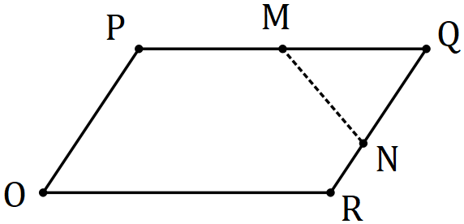 | $$\vec{OM}=p+\frac{1}{2}r$$  $$\vec{ON}=r+\frac{2}{5}p$$  $$\vec{MN}=\left(r+\frac{2}{5}p\right)-\left(p+\frac{1}{2}r\right) \\ =\frac{1}{2}r-\frac{3}{5}p$$
Specific behaviours
sketch
$\vec{OM}$
$\vec{ON}$
$\vec{MN}$

Question 20 (7 marks)
A small boat leaves jetty $A$ to travel to jetty $B$, $276$ m away on a bearing of $240°$. A steady current of $2.5$ ms⁻¹ runs in the river between the jetties on a bearing $130°$. If the small boat travels at a constant speed of $6.5$ ms⁻¹, determine the bearing it should steer to reach jetty $B$ and how long the journey will take.
Solution
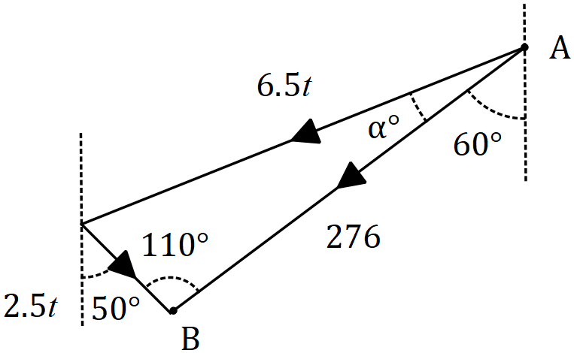

$$\frac{\sin{110}}{6.5t}=\frac{\sin{α}}{2.5t}$$

$$α=21.2°$$

$$180-110-21.2=48.8$$

$$\frac{\sin{110}}{6.5t}=\frac{\sin{48.8}}{276}$$

$$t=53 \text{seconds}$$

$$\text{Bearing: }240+21.2=261.2°$$

Specific behaviours
diagram
angle in triangle between current and $AB$
equation using sin rule for $α$
solves for angle offset $α$
equation using sin rule for $t$
correct time
correct bearing

Question 21 (7 marks)
A child is playing with thirteen coloured cubes, all the same size. There are six pink cubes, three navy and one each of red, blue, orange and green.

(a) If the child stacks cubes one on top of another to make a column, determine the number of different coloured columns that can be made using

(i) all the red, blue and green cubes. (1 mark)
Solution
$$3!=6$$

Specific behaviours
number

(ii) all the pink, red and orange cubes. (2 marks)
Solution
$$\frac{\left(6+1+1\right)!}{6!}=\frac{8!}{6!}=56$$

Specific behaviours
numerator
correct number

(iii) all the cubes. (2 marks)
Solution
$$\frac{13!}{6!3!}=1 441 440$$

Specific behaviours
expression
correct number

(b) If all but one of the cubes are used to make a column, determine the number of different coloured columns that can now be made. Justify your answer. (2 marks)
Solution
$$1 441 400 \text{columns}$$

All the columns 13 tall with a pink on top must have a difference in the 12 cubes beneath and so if the top pink is removed, the remaining columns will still be different.
The same is true for columns with other coloured top cubes, and the remaining 12 tall columns will have one less cube of the top colour and so must be different to all other columns.
So, no change.

Specific behaviours
correct number
justification

Supplementary page

Question number: _________

Supplementary page

Question number: _________

Supplementary page

Question number: _________

Supplementary page

Question number: _________

© 2018 WA Exam Papers. Baldivis Secondary College has a non-exclusive licence to copy and communicate this document for non-commercial, educational use within the school. No other copying, communication or use is permitted without the express written permission of WA Exam Papers. SN261-111-4.

